
RISE EYFS Reception Long-Term Curriculum Overview 2026-2027
Themes, Lines of Enquiry and Interests | Autumn 1  8 weeks | Autumn 2  8 weeks | Spring 1  6 weeks |  | Spring 2  4 weeks term  5 weeks of theme |  | Summer 1  8 weeks |  | Summer 2  4 weeks
Themes, Lines of Enquiry and Interests | Me and My World  Starting School  All About Me – What makes me special?  People who are special to me  Feelings/emotions  Science: (All About Me)  Different parts of the body and their function  Growth and Change  Senses  History: Family & Family Trees – diverse representations of family life  What I was like when I was a baby and how have I changed. When my family members were young – Timelines. Developing sense of chronology; before I was born, before I came to school, which classroom will I be in next year?  Birthdays. My past, present, future | Down in the Woods  Season of Autumn – changes taking place, hibernation, nocturnal animals  Halloween - Pumpkin Soup  Diwali  Bonfire Night – Light and Dark – sun, shadows, light in special celebrations  Christmas – Nativity Story and Performance  Geography: Our School  Science: Autumn – Hibernation, Nocturnal animals, changes to trees and environment  Autumn leaves (seasons, magnifying glass, textures)  Science: Sources of Light (Diwali and Bonfire Night) | Winter & Cold places  Science: Winter where we live - changes in environment. Knowing similarities and differences between the seasons  Changes in state - ice, snowflakes, how can we melt ice, why does ice melt? Animals within this Arctic and Antarctic and how they survive - animals and habitats  Geography: Arctic – contrasting environments, compare this to where we live. The coldest places on earth: North and South Poles, the globe,  History: Significant person – Earnest Shackleton – Describing the life of a historical character based on what has been read.  (Luna New Year, Shrove Tuesday) |  | King and Queens  Significant people who help us?  Geography - London and its landmarks  History: Locally significant areas in the past e.g. a local historical building Queen Elizabeth II’s coronation in Westminster Abbey.  New Life  Science: Signs of Spring - Farm animals and their babies Could link to Balanced Diets - Balanced diets, Teeth, Hygiene, Exercise Where does food come from? |  | How Things Grow  Science: Planting/Gardening  Life cycles of plant/sunflowers  From seed to plant – germination, how does a plant grow, what does a plant need to successfully grow.  Parts of a plant  Growing plants  Life cycles of Minibeasts – Frog/butterfly/  Geography: What is the purpose of a farm? How do animals give us produce? Where does food come from? What crops come from a farm?  History: Farm - Where does our food come from? History of tractors and farming |  | Wheels in Motion  History: Transport in the past and present: steam trains, hot air balloons, the first aeroplanes. Vehicles- past +present  Geography: Our Local Area – Location of our school and our local area, Maps and Plans  Following a to school route and describing it, what do I pass? Do I take transport? Understanding an address  Simple fieldwork  Going on a journey? – comparison of local area to somewhere else – Africa?  Science – Forces - pushes and pulls. Fun science/shadows - using the sun to make pictures  Seasons -Summer -sun safety Transport in the winter; snow ploughs, gritting roads, snow tyres.  Going on holiday  Send me a postcard!  Seasides, games and toys in the past  Marine life  Fossils – Mary Anning
Links to KS1 Curriculum | Year 1 Science AIH (Senses) (Week 7)  Year 1 History – Changes in Recent Memory (Week 11 & 12)  Year 2 Geography – Local Area Study (Week 27 & 28) | Year 1 Geography School Locality (Week 1 & 2)  Year 1 Science Seasonal Changes (Week 3 & 4)  Year 1 Science – Animals and What they Need (24 & 25)  Year 2 Science – Habitats ( Week 3 & 4) | Year 1 Science – Animals and What they Need (24 & 25)  Year 1 Geography – Hot and Cold Places (Week 28 & 29)  Year 1 History – Significant People (Walter Tull, George Stephenson)  Year 2 Geography – Continents (Week 1 & 2)  Year 2 Science – Habitats ( Week 3 & 4)  Year 2 History – Explorers (Week 13 & 14)  Year 2 Geography – Comparison Study (Week 16 & 17) |  | Year 1 History – Parliament and Royalty (Week 22 & 23)  Year 2 Geography London Over Time (Week 8 & 9) |  | Year 1 Science - Plants (Week 21)  Year 2 Science – Plants (Week 25 & Week 26) |  | Year 1 Science Seasonal Changes (Week 3 and 4)  Year 1 History – George Stephenson  Year 1 Geography Oceans and Seas (Week 18/19)  Year 1 Geography – Life in the U.K. (Week 9 & 10)
Key Texts | 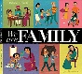  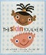  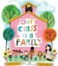  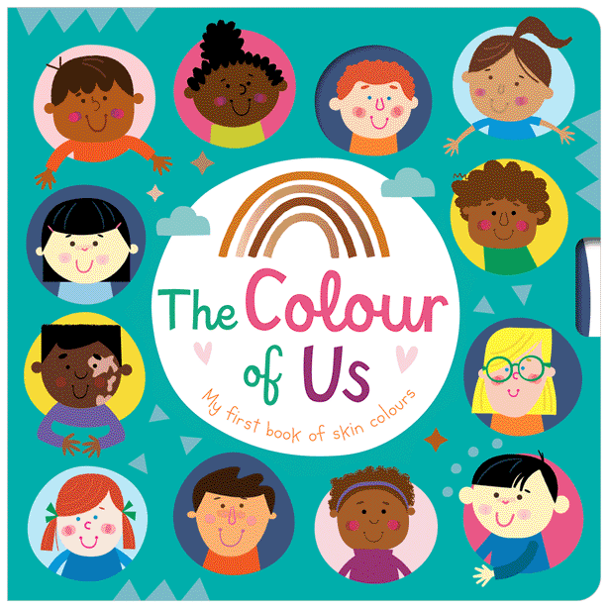  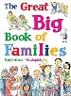  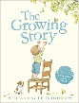  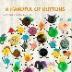  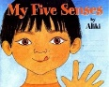  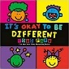  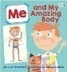  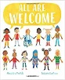  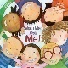  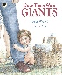  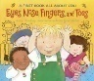    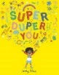  What I Like About Me by Alia Zobel-Nolan or Super Duper You! – Sophy Henn  All are Welcome – Alexandra Penfold and Suzanne Kaufman or My Word, Your World - Melanie Walsh  Eyes, Nose, Fingers and Toes – Judy Hindley  Me and my Amazing Body – Joan Sweeny  It’s Okay to be different – Todd Parr  My Five Senses - Aliki  The Great Big Book on Families – Mary Hoffman or A handful of Buttons – Carmen Parets Luque or We are a Family – Patricia Hegarty  The Growing Story – Ruth Krauss and Helen Oxenbury  Once There Were Giants - Martin Waddell  The Colour of Us – Lezette Rivera and Christie Hainsby | 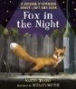  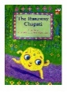  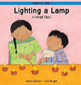  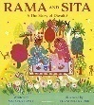  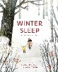  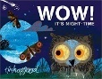  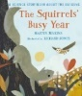  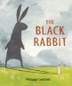  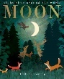  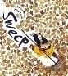  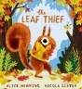  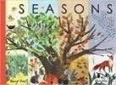  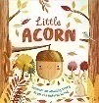  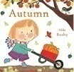  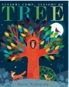  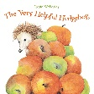  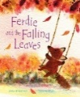  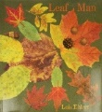  Leaf Man – Lois Ehlert  Ferdie and the Falling Leaves - Julia Rawlinson  The Very Helpful Hedgehog- Rosie Wellesley  Hibernation Hotel - John Kelly  Tree – Britta Teckentrup  Autumn - Ailie Busby  Little Acorn –  Seasons – Hannah Pang  The Leaf Thief – Alice Hemming  Sweep – Louise Greig  Moon – Patricia Hegarty  Fox in the Night – Martin Jenkins  The Black Rabbit – Philippa Leathers  The Squirrels Busy Year – Martin Jenkins  Wow! Its night-time – Tim Hopgood  Winter Sleep – Sean Taylor  Lighting a Lamp – Jonny Zucker  Rama and Sita –  The Runaway Chapatti – Susan Price | 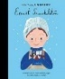  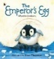  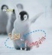  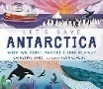  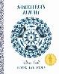  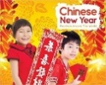  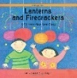  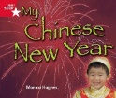  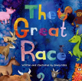  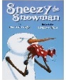  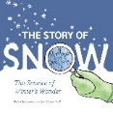  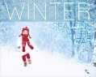  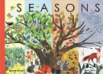  Seasons – Hannah Pang  Winter -  The Story of Snow – Jon Nelson  Sneezy the Snowman – Maureen Wright  The Great Race – Emily Hiles  My Chinese New Year –  Lanterns and Fireworks – Johnny Zucker  Chinese New Year – Grace Jones  Shackleton’s Journey - William Grill  Let’s Save Antarctica – Catherine Barr  Egg to Penguin – Camilla de la Bedoyere  The Emperors Egg – Martin Jenkins  Ernest Shackleton – Maria Isabel Sanchez Vegara |  | 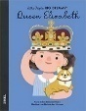  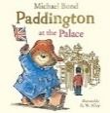  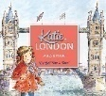  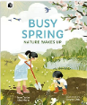  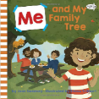  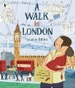  Queen Elizabeth II – Little people, Big dreams - Maria Isabel Sanchez Vegara  Katie in London - James Mayhew  Paddington at the Palace – Michael Bond  A Walk in London - Salvatore Rubbino  Me and My Family Tree - Joan Sweeny  Busy Spring – Sean Taylor |  | 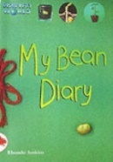  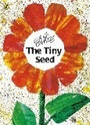  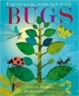  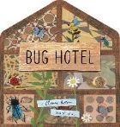  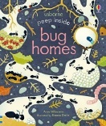  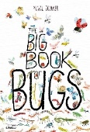  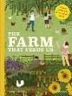  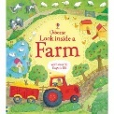  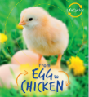  Egg to Chicken (Life cycles) – Camilla de la Bedoyere  Look Inside a Farm – Katie Daynes  The Farm that Feed Us – Nancy Castaldo  Old Mikamba had a Farm – Rachel Isadora  Peep Inside Bug Homes – Anna Millbourne  The Big Book of Bugs – Yuval Zommer  Bug Hotel – Libby Walden  Bugs – Patricia Hegarty  The Tiny Seed – Eric Carle  My Bean Diary – Discovery World |  | 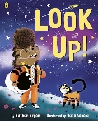  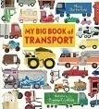  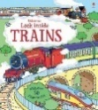  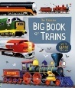  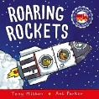  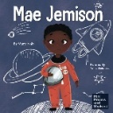  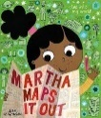  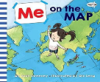  Me on the Map – Joan Sweeny  Martha Maps it Out – Leigh Hodgkinson  Roaring Rockets – Tony Mitton  The Big Book of Transport – Moira Butterfield  Mae Jemison – Mary Nhin  Look Up – Nathan Bryon  Look Inside Trains – Alex Frith
Literacy Teaching texts | 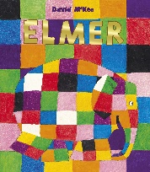  Elmer  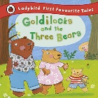  Goldilocks and the Three Bears  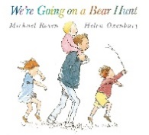  We’re Going on a Bear Hunt – Michael Rosen  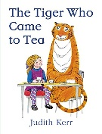  The Tiger Who Came to Tea – Judith Kerr  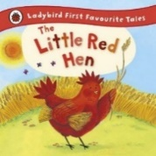  The Little Red Hen | 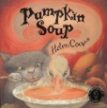  Pumpkin Soup – Helen Cooper  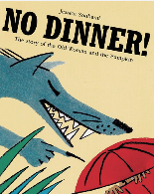  No Dinner – Jessica Souhami  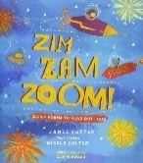  Zim Zam Zoom – Firework Poem  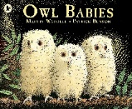  Owl Babies – Martin Waddel  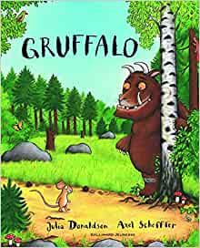  The Gruffalo – Julia Donaldson | 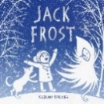  Jack Frost    The Great Explorer – Chris Judge  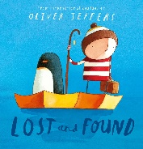  Lost and Found-Oliver Jeffers  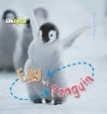  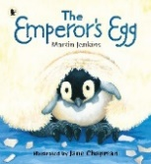  The Emperor’s Egg  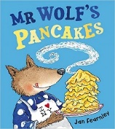  Mr Wolf’s Pancakes - Instructions/ Verbal sequencing |  | 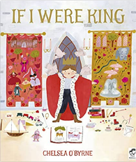  If I Were King  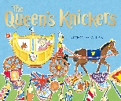  The Queen’s Knickers  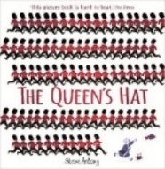  The Queen’s Hat  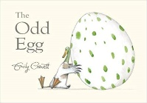  The Odd Egg- Emily Gravitt  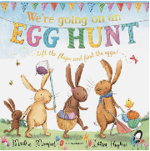  We’re Going on an Egg Hunt  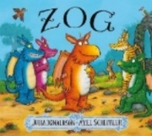  Zog |  | 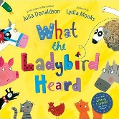  What the Ladybird Heard - Julia Donaldson  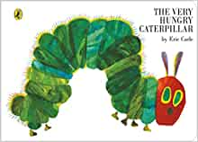  The Very Hungry Caterpillar  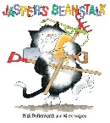  Jasper’s beanstalk  Instructions  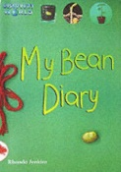  Non-fiction: Growing a bean  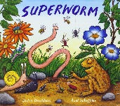  Superworm - Julia Donaldson  Jack and the beanstalk |  | 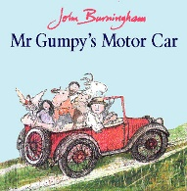  Mr Gumpy’s Motor Car/Outing  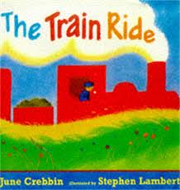  The Train Ride  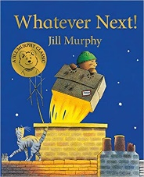  Whatever Next – Jill Murphy  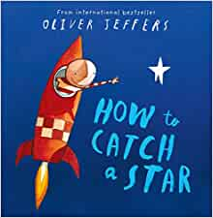  How to Catch a Star – Oliver Jeffers  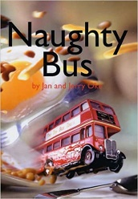  Naughty Bus
Key Experiences and Festivals | Harvest Festival  Walk around the school grounds  Choose a tree to photograph throughout the year  Walk in the local area, mapping where children live. Walk around the local area and comparing houses  Show and tell – any new born siblings, grandparents Any people who help within the community; police, nurses, fire service etc | Bonfire Night 5th November  Remembrance day 11th November  Diwali - Festival of Lights 14th November  Christmas - 25th December  Autumn Welly Walk  Discuss own experiences/ celebrations ie birthday and Christmas  Making bread/Vegetable soup  Nativity performance - Church Service  Stay and Play sessions  Posting a letter - Walking to the Post Office to post a Christmas card | Shrove Tuesday  Ash Wednesday  Valentine’s Day  World Book Day  Luna New Year – Making and eating Chinese Noodles/Stir Fry. Food tasting & cooking– different cultures |  | Holi  Easter  Mothering Sunday  Local site of historical interest relating to the Monarchy e.g. a stately home, castle, palace etc.  Member of the school community who can talk about Easter- links to local churches |  | Eid  Father’s Day  Local garden centre, ecological or botanical project or attraction. |  | Transition days  Transport museum, local attraction with historical transport.
Communication & Language   | Throughout the year there will be a focus on spoken language – this will be evident in children’s play and the interactions between staff and children as well as children and children.  Examples of CAL within the Early Years are oral story-telling, nursery rhymes, high quality talk, Talk Boost intervention, daily story time, learn and embed new vocabulary, story mapping, daily singing, Makaton signs, visual support and listening games.  All children are screened at the start of the year using TalkBoost.
 | Autumn 1 | Autumn 2 | Spring 1 |  | Spring 2 |  | Summer 1 |  | Summer 2
 | Listen to others one on one or in small groups, e.g. talk about families in circle time and share pictures. Understand how to listen carefully and why listening is important.  Listen to stories, rhymes, poems and songs. Join in with repeating refrains and anticipating key events and phrases in rhymes and stories e.g. in songs, poems, familiar stories, call and response games.  Understand use of objects and tools in the classroom e.g. children know what they can do during independent free flow time, they know how to select the tools they need to make a junk model, to write a letter to someone etc.  Respond to multi-step instructions e.g. first we need to put our coats on, then we need to zip them up, then we will get ready to go out to play.  Retell past events from stories and from own experience in chronological order; e.g. describing a day at school, describing what they did at the weekend, talking about what happened in a story. Begin to use time related vocabulary for the school day such as morning, lunchtime, afternoon. | Begin reciting learnt Nursery Rhymes by heart.  Join in with repeated refrains and familiar stories. Begin to orally retell stories using story props.  Follow directions, recognising left and right e.g. in games such as Simon says Show understanding of prepositions such as ‘under, on top’ e.g. when tidying the classroom children can say where things belong.  Use vocabulary, including phrases, from recently read stories in conversations e.g. children can talk about nocturnal animals and what this means  Ask questions using what, where, when and why to find out information, e.g. when learning about things from the past, children can ask questions to find out more and to check they understand what has been said to them | Articulate their ideas and thoughts in well-formed sentences. Connect one idea or action to another using a range of connectives.  Listen to and talk about selected non-fiction to develop a deep familiarity with new knowledge and vocabulary.  Build up vocabulary that reflects knowledge and experience e.g., children can talk about cold places, what they know about them, how animals survive, describe the changes in seasons and states of matter.  Use different tenses to discuss things that are happening now and things that happened in the past, and things that happened a very long time ago.  Ask relevant questions to find out more information e.g. when sharing a non-fiction text children can say ‘I wonder why…’  Share opinions, explaining preferences e.g. My favourite season is… because… |  | Ask and answer questions about stories.  Describe events in some detail.  Use talk to help work out problems and organise thinking and activities explain how things work and why they might happen.  Describe a pretend object in play based situations, e.g. when role playing a coronation a child might use props for their orb and sceptre.  Focus attention in a variety of situations; in small groups, 1:1 and whole class  Use increasingly complex sentences to link thoughts e.g. using ‘and’, ‘because’. E.g. this is happening because…  Understand ‘how’ and ‘why’ questions and use them in a variety of contexts e.g. how do people change as they grow? |  | Question to understand why things happen e.g. who, what, when, how e.g. when a visitor comes in to talk to the class, children can ask questions rather than just sharing information they know.  Use intonation and rhythm when joining in with stories and rhymes  Respond to questions using full sentences, e.g. I think… because… this will be consistently modelled by adults in all curriculum areas  Use newly acquired vocabulary to name and describe, and in conversations e.g. children can discuss their plants, how they cared for them and what they noticed.  Apply new vocabulary to explain changes noticed in plants. |  | Speaking in well-formed sentences. Back and forth conversations between them and their peers and adults. Respond to comments from peers using full sentences, e.g. I agree with … because…  Use new vocabulary in different contexts.  Use talk to explain what is happening and anticipate what might happen next e.g. when reading about a story, children might explain what they think might happen to a character.  Recall and relive past experiences; discuss special events, birthdays, in school celebrations etc.  Retell the story once they have developed a deep familiarity with the text; some as exact repetition and some in their own words. Retell events in order e.g. ordering events from the stories that they’ve shared in class.  Explain ideas and experiences using different tenses, prepositions, temporal connectives and vocabulary acquired from all areas of the curriculum. This will be modelled by adults consistently.
Learn new vocabulary.
Use new vocabulary through the day.
Use new vocabulary in different contexts.
Listen carefully to rhymes and songs, paying attention to how they sound.
Learn rhymes, poems and songs.
ELG | ELG: Listening, Attention and Understanding  Listen attentively and respond to what they hear with relevant questions, comments and actions when being read to and during whole class discussions and small group interactions.  Make comments about what they have heard and ask questions to clarify their understanding.  Hold conversation when engaged in back-and-forth exchanges with their teacher and peers. |  |  |  | ELG: Speaking  Participate in small group, class and one-to-one discussions, offering their own ideas, using recently introduced vocabulary.  Offer explanations for why things might happen, making use of recently introduced vocabulary from stories, non-fiction, rhymes and poems when appropriate.  Express their ideas and feelings about their experiences using full sentences, including use of past, present and future tenses and making use of conjunctions, with modelling and support from their teacher.
  Personal, Social & Emotional Development | Throughout the year there will be a focus on PSED through the scheme SCARF within the Early Years. This will be evident in children’s self-regulation and executive function.  Long-term planning for areas of continuous provision will highlight different elements of PSED for all areas of provision. Examples of PSED in action within the Early Years are daily mindfulness sessions, giving vocabulary to feelings through story and the introduction of strategies to support emotional regulation.
 | Autumn 1 | Autumn 2 | Spring 1 |  | Spring 2 |  | Summer 1 |  | Summer 2
 | Me & my family. Transition from home to school. Building relationships with EY staff.  Our classroom and school rules; how we all help to make our classroom a happy place to learn.  My Feelings; words I can use to describe how I am feeling. What I can do when I am angry or upset Expressing and naming own feelings. Emotion stones.  Me and My Relationships  All about me  What makes me special  Me and my special people  Valuing Differences  I’m Special, you’re special  Same and different  Same and different homes  Growing and Changing  Life Stages  Community and people who help us | Expressing individuality- likes and interests. Sense of self as an individual.  Including everyone; diversity within our school and the wider community.  Being responsible.  Building relationships with other children  Me and my Relationships  Feelings  My Feelings (2)  Valuing Differences  I am Caring  I am a Friend | My Community.  Teamwork and sharing; working together and waiting to take turns How can I help my friends?  Considering the feelings of others.  Rights and Responsibilities  Looking after my special people  Looking after my friends  Being helpful at home  Caring for our world  Looking after money |  | Express preferences and decisions.  Introduce class jobs. Changes as we get older. Life stages.  Being My Best  Bouncing back when things go wrong  Yes I can!  Healthy Eating  Healthy Mind  Move your body  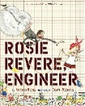  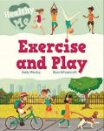  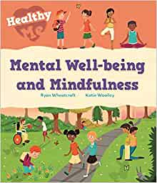  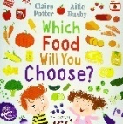  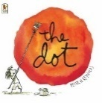 |  | Healthy diets to help us grow; what we need to eat, how we look after our bodies and keep ourselves clean. Brushing teeth, hand washing  Visit from dentist/school nurse  Resilience, perseverance and challenge through social stories and inspirational people. What do I do when things are hard?  Growing and Changing  Looking at Seasons  Life stages: plants, animals, humans  Life stages: Who will I be?  Where do babies come from?  Getting bigger  Me and my body: Girls and Boys |  | Challenges: moving to Year One Perseverance Who can help me at school?  Doing things myself and helping others. Independence. What can I do if I am worried?  Keeping myself safe  Keeping myself safe - Road Safety  What’s safe to go on to my body  What’s safe to go into my body  Safe indoors and outdoors  Listening to my feelings  Keeping safe online  People who help keep me safe
ELG | ELG: Self-Regulation - Show an understanding of their own feelings and those of others, and begin to regulate their behaviour accordingly.  Set and work towards simple goals, being able to wait for what they want and control their immediate impulses when appropriate.  Give focused attention to what the teacher says, responding appropriately even when engaged in activity, and show an ability to follow instructions involving several ideas or actions. |  |  | ELG: Building Relationships  Work and play cooperatively and take turns with others.  Form positive attachments to adults and friendships with peers.  Show sensitivity to their own and to others’ needs. |  |  |  | ELG: Managing Self Children  Be confident to try new activities and show independence, resilience and perseverance in the face of challenge.  Explain the reasons for rules, know right from wrong and try to behave accordingly.  Manage their own basic hygiene and personal needs, including dressing, going to the toilet and understanding the importance of healthy food choices.
  Physical Development | Throughout the year, there will be a focus on PD within The Early Years.  Daily opportunities to practise fine motor skills through classroom provision and Dough Disco/Pen Disco activities. Daily handwriting/letter formation. Access to outdoor provision where children will develop their gross motor skills across the year.
 | Autumn 1 | Autumn 2 | Spring 1 |  | Spring 2 |  | Summer 1 |  | Summer 2
Gross Motor | Spatial awareness and multi step instruction games Running, jumping, using tricycles and scooters outside with increasing control. | Spatial awareness and coordination games, throwing and catching Dance to music, moving with control around the floor | Invasion games, throwing and catching Balance- standing on one leg, walking along a bench, climbing. |  | Team games and ball skills including using a racquet Running, jumping, hopping from foot to foot, running around obstacles |  | Team games including relay races, using racquets and balls, throwing and catching Running, jumping, hopping, skipping, jumping over obstacles, skipping with a rope |  | Racing and obstacle courses – skills for sports day Running, jumping, hopping, skipping, travelling under and over obstacles, throwing and catching
Fine Motor | Small tools; cutlery, tweezers, pipettes, scissors. Cutting paper, card, fabric, tracing, using templates, playdough Drawing myself; what features do I have?  Drawing Maps | Small tools; cutlery, tweezers, pipettes, scissors  Drawing, painting and modelling dough animals  Chopping/peeling vegetables for winter soup | Small tools; cutlery, tweezers, pipettes, scissors Drawing and painting, |  | Small tools; cutlery, tweezers, pipettes, scissors. Cutting shapes e.g. spirals, pencil control |  | Small tools; cutlery, tweezers, pipettes, scissors. Cutting shapes e.g. spirals, pencil control  Drawing and painting plants and flowers, leaf rubbings  Using woodworking tools to make bee houses – Hammers, Saws |  | Small tools; cutlery, tweezers, pipettes, scissors. Cutting textured paper, tracing, using templates, playdough  Drawing, painting, weaving or simple sewing  Drawing maps, transport, junk modelling vehicles
ELG | Gross Motor Skills ELG  Negotiate space and obstacles safely, with consideration for themselves and others  Demonstrate strength, balance and coordination when playing  Move energetically, such as running, jumping, dancing, hopping, skipping and climbing. |  |  |  | Fine Motor Skills ELG  Hold a pencil effectively in preparation for fluent writing – using the tripod grip in almost all cases.  Use a range of small tools, including scissors, paint brushes and cutlery.  Begin to show accuracy and care when drawing.

Literacy
Comprehension, word reading, writing

 | Autumn 1 | Autumn 2 | Spring 1 |  | Spring 2 |  | Summer 1 |  | Summer 2
 | Comprehension  Fiction including picture books with familiar settings, relating to families, people who help us.  Understand print carries meaning  Show interest in books  Predict story endings  Join in rhyming and rhythmic activities Listening and participating during whole class English sessions  Commenting on stories  Joining in with repeated refrains of familiar stories  Sequencing stories  Giving personal responses to texts  Oral retelling of familiar stories using own words and recently introduced vocabulary.  Story language; becoming familiar with phrases like ‘once upon a time’, ‘a long time ago’, ‘lived happily ever after’.  Use puppets to retell familiar stories.  Poetry; learning and reciting simple poems with rhyme and repetitive language  Word Reading  Initial code and simple CVC words in line with Sounds Write  To orally start to segment the sounds in words and blend them together.  Continues a rhyming string and identifies alliteration.  Hears and says the initial sound in words.  I can identify known letters to match initial sounds (Initial code taught)  Writing  Give meaning to marks made  Emergent writing – writing for a purpose within provision.  Begins to break the flow of speech into words  Write name  Writing labels  Provide opportunities for mark making; stamps in playdough, wheels and other shapes for stamping into playdough, carving into fruit and vegetables.  Upright mark making such as an easel, a tuff tray on its side, painting with water onto walls, window paints etc.  Letter formation  Pencil control  Begins to make letter-type shapes to represent the initial sound of familiar words. | Comprehension  Fiction & Non fiction books about Autumn and Celebrations.  Demonstrate understanding of books that have been read to them: To suggest how a story might end. To be able to name characters and talk about key events in stories. Identify and anticipate key events in familiar stories including repeated refrains. To begin to recall facts from non-fiction.  Continue to join in rhyming and rhythmic activities  Role play; using imaginative movement and vocabulary to recreate scenes from familiar stories  Word Reading  Initial code and simple CVC words and more in line with Sounds Write  I can identify known letters to match initial sounds (Initial Code Unit 1-7)  I can start to orally blend the sounds together to read and write CVC words and labels e.g. c-a-t with the sounds taught  I am starting to read captions e.g. the cat and the dog  Writing  Write name without a name card.  Give meaning to marks made.  Writing Simple Labels and lists  Enjoys creating texts to communicate meaning for an increasingly wide range of purposes, such as making greetings cards, tickets, lists, invitations.  Provide opportunities for emergent writing (with ongoing provision for mark making) e.g. writing letters of children’s names in paint, sand, with water and brushes, tracing activites, rubbing activities, whiteboards and pens, clipboards outside etc.  Letter formation  Pencil control  To begin to write some lower case letters correctly. | Comprehension  Fiction & Non-fiction texts about space - Use and understand recently introduced vocabulary during discussions about stories, non-fiction, rhymes and poems.  To retell a story, remembering the beginning, middle and end.  Word Reading  Reading words through sound blending as part of Sounds Write  Begins to segment the sounds in simple words and blend them together and knows which letters represent some of them.  To read words consistent with their phonic knowledge by sound blending.  Starts to link sounds to letters, naming and sounding the letters of the alphabet.  I can segment and blend CVC words and spell words by identifying sounds in them and representing the sounds with a letter or letters.  I can read simple captions  Writing  I can say a simple sentence for writing (oral and count words)  Segment words orally  Uses their developing phonic knowledge to write things such as CVC words, labels and captions, messages which can be read by self and others  Emergent writing; encourage short words or phrases in different writing contexts, e.g. in free flow or in a structured lesson.  Represent some sounds correctly and in sequence, writing words containing taught sounds.  Enjoys creating texts to communicate meaning for an increasingly wide range of purposes, such as making greetings cards, tickets, lists, invitations.  Provide opportunities for emergent writing (with ongoing provision for mark making) e.g. writing letters of children’s names in paint, sand, with water and brushes, tracing activites, rubbing activities, whiteboards and pens, clipboards outside etc.  Letter formation  Focus on letter formation in line with handwriting policy |  | Comprehension  Fiction & Non-fiction texts about the monarchy, history etc.  Role play using newly acquired vocabulary e.g. role play a coronation  Children can annotate pictures of monarchs with speech bubbles and thought bubbles.  To retell a story, remembering the beginning, middle and end.  Use and understand recently introduced vocabulary during discussions about stories, non-fiction, rhymes and poems.  Word Reading  Recognise common exception words within a Read Write Inc  Read and understand simple sentences in stories and information books using phonic knowledge to decode regular words and read aloud accurately  To read words and sentences consistent with their phonic knowledge by sound blending.  Writing  Labelling e.g labelling seed pots  Descriptive sentences; children begin to write to describe an object eg. The seed is tiny. The plant is tall.  Letter writing including simple sentences and phrases  Write short phrases and sentences using growing knowledge of phonics to attempt unknown spellings  Write own labels, captions, messages, simple stories, which can be read by self and others.  Provide opportunities for emergent writing (with ongoing provision for mark making) e.g. writing letters of children’s names in paint, sand, with water and brushes, with pens, pencils etc.  Focus on letter formation in line with handwriting policy |  | Comprehension  Fiction & Non-fiction texts about how people, animals and plants grow.  Verbal sequencing using temporal connectives. E.g. First I climbed on the climbing frame, then I slid down the big slide!  Word Reading  Read sentences in stories and information books  Decode regular words  Writing  Descriptive sentence writing  Instructions; writing simple instructions for a familiar process in a numbered list.  Create fact books about Plants and Minibeasts and notice the difference between writing stories and writing information.  Write simple phrases and sentences with phonetically plausible attempts at unknown spellings. Use phonic knowledge to spell words in ways which match sounds. Use high frequency words in writing  To write words containing sounds taught, including taught digraphs.  To start to use finger spaces between my words  To read sentences back  To read and spell some tricky words.  Begins to link sounds to some frequently used digraphs, e.g. sh, th, ee  Ongoing provision for emergent writing and creative mark making e.g. playdough and letter stamps, clipboards and paper, painting on an upright tuff tray, writing with fingers in sand, rice etc.  Extending my writing and using connectives – making our writing stronger and longer.  Letter formation  I can write most lower case letters correctly  I can use a tripod grip. |  | Comprehension  Fiction & Non-fiction books about the past.  Jumping into the story Settings- what was the character thinking at this point in the story?  Character profiling; what do we know about ______?  Nonsense poetry- how authors play with words  Creating our own stories (orally or written) with a Beginning, middle and end.  To use new vocabulary from stories throughout my play and when making up my own stories  Use and understand recently introduced vocabulary during discussions about stories, non-fiction, rhymes and poems.  I can recall facts from a non- fiction book.  Word Reading  Read and spell regular words of more than 1 syllable  Read irregular, high frequency words  Read simple stories and describe main events  Writing  Write simple phrases and sentences, making phonetically plausible attempts at writing newly acquired vocabulary.  Use key features of narrative in own writing.  Using descriptive language in oral storytelling and in writing.  Instructions; writing numbered lists in a logical order.  Using finger spaces, capital letters and full stops  Letter formation  I can write some upper case letters correctly.  Descenders are sittng below the line.
Phonics-  Sounds Write  Initial Code  Daily Phonics - Sounds Write | Initial Code: Units 1-4  • Unit 1 (2 wks)  • Unit 2 (2 wks)  • Unit 3 (2 wks)  • Unit 4 (2 wks)  Segment, blend and manipulate sounds in words with the structure CVC  m, a, t, s, i, n ,o ,p, b, c, g, h  Sight Words  is, a, said, the, I, | Initial Code: Units 5-7  • Unit 5 (2 wks)  • Unit 6 (2 wks)  • Unit 7 (2 wks)  Segment, blend and manipulate sounds in words with the structure cvc  d, f, v, e, k, l, r, u, j, w  Sight Words  for, of, are, he, was, she, | Initial Code: Units 8 – 10  • Unit 8 (2 wks)  • Unit 9 (2 wks):  Wk 1 CCVC (continuants)  Wk 2 CCVC (noncontinuants)  + Unit 11 /sh/  (fish/mash CVC)  • Unit 10 + continuing Unit  11  Segment, blend and manipulate sounds in words with the structure cvc  z, w, x, y, ff, ll, ss, zz  Sight Words  all, come, some, to, |  | Continuing the Initial Code: Units 8 – 10  • Unit 8 (2 wks)  • Unit 9 (2 wks):  Wk 1 CCVC (continuants)  Wk 2 CCVC (noncontinuants)  + Unit 11 /sh/  (fish/mash CVC)  • Unit 10 + continuing Unit  11  Segment, blend and manipulate sounds in words with the structure cvc  Introduce building vcc, cvcc, ccvc words with prior learnt sounds |  | Initial Code: Unit 10 to run  concurrently with:  Initial Code: Unit 11)  • Unit 11 - /sh/ - < sh >  • Unit 11 - /ch/ - < ch >  • Unit 11 - /th/ - < th >  un/voiced  • Unit 11 - /k/ - < ck >  • Unit 11 - /ng/ - < ng > &  < n >  • Unit 11 - /k/w/ - < q > < u>  • Unit 11 - /w/ - < wh >  Segment, blend and manipulate sounds in words with the structure ccvcc  Bridging Units
ELG | Comprehension ELG  Demonstrate understanding of what has been read to them by retelling stories and narratives using their own words and recently introduced vocabulary.  Anticipate – where appropriate – key events in stories.  Use and understand recently introduced vocabulary during discussions about stories, non-fiction, rhymes and poems and during role-play. |  | Word Reading ELG  Say a sound for each letter in the alphabet and at least 10 digraphs.  Read words consistent with their phonic knowledge by sound-blending.  Read aloud simple sentences and books that are consistent with their phonic knowledge, including some common exception words. |  |  |  | Writing ELG  Write recognisable letters, most of which are correctly formed.  Spell words by identifying sounds in them and representing the sounds with a letter or letters.  Write simple phrases and sentences that can be read by others.
Mathematics  White Rose | There will be a focus on Mathematics and playing games using loose parts during the year. Long-term planning for areas of continuous provision will highlight different elements of Mathematics within all areas of provision.
Mathematics  White Rose | Autumn Term |  | Spring Term |  |  |  | Summer Term
Mathematics  White Rose | Getting to know you - Opportunities for settling in, introducing the areas of provision, getting to know the children.  Key times of day, class routines.  Match, Sort and Compare  Match objects  Match pictures and objects  Identify a set  Sort objects into a type  Explore sorting techniques  Create sorting rules  Compare amounts  Talk about Measure and Patterns – Compare size, compare mass, compare capacity, explore simple patterns, copy and continue simple patterns, create simple patterns.  It’s me 1,2,3,  Find 1,2 and 3  Subitise 1,2 and 3  Represent 1,2, and 3  1 more, 1 less  Composition of 1,2 and 3  Circles and Triangles- Identify and name circles and triangles, compare circles and triangles, shapes in the environment, describe position  1,2,3,4,5  Find 4 and 5  Subitise 4 and 5  Represent 4 and 5  1 more, 1 less  Composition of 4 and 5  Composition of 1-5  Shapes with 4 sides – Identify and name shapes with 4 sides, combine shapes with 4 sides, Shapes in the environment, My day and night |  | Alive in 5  Introducing zero  Find 0 to 5  Subitise 0 to 5  Represent 0 – 5  1 more  1 less  Composition  Conceptual subitising to 5  Mass and Capacity - Compare Mass. Find a balance. Explore capacity, Compare capacity  Growing 6,7,8  Find 6,7 and 8  Represent 6,7,8  1 more  1 less  Composition of 6,7 and 8  Making pairs – odd and even  Double to 8 (find a double)  Double to 8 (make a double)  Combining two groups  Conceptual subitising  Length, height and time  Explore length, compare length, compare height, talk about time, order and sequence time  Building 9 and 10  Find 9 and 10  Comparing numbers to 10  Representing 9 and 10  Conceptual subitising to 10  1 more  1 less  Composition to 10  Bonds to 10 (2 parts)  Make arrangements to 10  Bonds to 10 (3 parts)  Doubles to 10 (find a double)  Doubles to 10 (make a double)  Explore even and odd  Explore 3D shapes  Recognise and name 3D shapes  Find 2D shapes with 3D shapes  Use 3D shapes for tasks  3D shapes in the environment  Identify more complex patterns  Copy and continue patterns  Patterns in the environment |  |  |  | To 20 and beyond  Building numbers beyond 10 (10-13)  Continue Patterns beyond 10 (10-13)  Build numbers beyond 10 (14-20)  Continue Patterns beyond 10 (14-20)  Verbal counting beyond 20  Verbal counting patterns  How Many Now?  Add more  How many did I add?  Take away  How many did I take away?  Manipulate, compose and decompose  Select shapes for a purpose  Rotate shapes  Manipulate shapes  Explain shape arrangements  Compose shapes  Decompose shapes  Copy 2D shape pictures  Find 2D shapes within 3D shapes  Sharing and Grouping  Explore sharing  Sharing  Explore Grouping  Grouping  Even and odd sharing  Play with and build doubles  Visualise, build and map  Identify units of repeating patterns  Create own pattern rules  Explore own pattern rules  Replicate and build scenes and constructions  Visualise from different positions  Describe positions  Give instructions to build  Explore mapping  Represent maps with models  Create own maps from familiar places  Create own maps and plans from story situations  Make connections  Deepen understanding  Patterns and relationships
Mathematics  White Rose | ELG: Number  Have a deep understanding of number to 10, including the composition of each number; 14.  Subitise (recognise quantities without counting) up to 5;  Automatically recall (without reference to rhymes, counting or other aids) number bonds up to 5 (including subtraction facts) and some number bonds to 10, including double facts. |  |  |  | ELG: Numerical Patterns Verbally count beyond 20, recognising the pattern of the counting system.  Compare quantities up to 10 in different contexts, recognising when one quantity is greater than, less than or the same as the other quantity.  Explore and represent patterns within numbers up to 10, including evens and odds, double facts and how quantities can be distributed equally.
  Understanding The World | Within Understanding the World we are developing knowledge which builds into a bigger picture of understanding, providing our children with foundational knowledge which will equip our children for success later in their primary education.  Throughout the year, there will be a focus on seasonal changes and nature – this will be evident in children’s play and the interactions between staff and children as well as experiences provided and play. Concepts are built on and developed over time, carefully linked and planned with key vocabulary introduced and explored. The majority of teaching will be lead through high quality texts. Examples of UTW within the Early Years are daily opportunities to observe the seasons and the weather and recording this, discussing weather daily and gardening throughout the year.
 | Autumn 1 | Autumn 2 | Spring 1 |  | Spring 2 |  | Summer 1 |  | Summer 2
Past and Present  (History) | History - Me and My Family  What is a family? Diverse representations of family life. Share photographs. Family trees - Who is in my family? Stories about families, Developing sense of chronology; before I was born, before I came to school, which classroom will I be in next year? Timelines, Family Trees, What I was like when I was a baby? Share photographs as children as babies and as they are now. What has changed?  Talk about members of their immediate family and community. (DM)  Name and describe people who are familiar to them. (DM)  Comment on images of familiar situations in the past. (DM)  Talk about the lives of people around them and their roles in society. (ELG) |  | History - Ernest Shackleton the explorer; The South Pole, the challenges of his journey Describing the life of a historical character based on what has been read.  • Compare and contrast characters from stories, including figures from the past. (DM)  • Understand the past through settings, characters and events encountered in books read in class and storytelling. |  | History - Kings and Queens (The Royal Family)  Queen Elizabeth ll, Members of the Royal Family, Role of the Queen, Queen Elizabeth II’s coronation in Westminster Abbey.  Family tree, Line of succession, Buckingham Palace, Windsor Castle, Balmoral Castle, Queen Victoria, Jubilee.  Comment on images of familiar situations in the past. (DM)  • Compare and contrast characters from stories, including figures from the past. (DM).  • Understand that some places are special to members of their community. (DM)  • Talk about the lives of the people around them and their roles in society;  • Know some similarities and differences between things in the past and now, drawing on their experiences and what has been read in class;  • Understand the past through settings, characters and events encountered in books read in class and storytelling. |  | History - How things grow  Farming in the past; locally relevant information e.g. local areas that used to be farmland, what was grown, what those areas look like now. How farming worked in the past; use of horses and carts, horses and cows pulling ploughs. Present day use of machinery in farming. |  | History – Transport in the Past George Stevenson; The invention of the Steam Train Transport in the past; horse and carriage, motor cars, penny farthing, omnibus, ferry, other locally relevant transport from history. Modern transport including the Japanese Bullet Train, hovercraft, racing cars, aeroplanes and other examples of technologically advanced transport.  • Comment on images of familiar situations in the past. (DM)  • Compare and contrast characters from stories, including figures from the past. (DM)  • Talk about the lives of the people around them and their roles in society;  • Know some similarities and differences between things in the past and now, drawing on their experiences and what has been read in class;  • Understand the past through settings, characters and events encountered in books read in class and storytelling.
People, Culture and Communities (Geography) | Geography: The world around me  Our Local Area - Describing places in our local area  Maps and Plans - Draw maps & plans of our school/ homes/ classrooms.  My route to school; what do I pass? Do I take transport? Following a route and describing it, Understanding an address  Simple fieldwork  Community; this means the people who feature in our lives, our school is an important part of our community, friends, families, religious communities, people with shared interests e.g. hobbies. People who help us in our community; including but not limited to teachers, doctors and nurses, firefighters, police  Talk about members of their immediate family and community. (DM)  • Draw information from a simple map. (DM)  • Understand that some places are special to members of their community. (DM)  • Recognise some environments that are different to the one in which they live. (DM)  • Talk about the lives of the people around them and their roles in society;  • Describe their immediate environment using knowledge from observation, discussion, stories, non-fiction texts and maps;  • Explain some similarities and differences between life in this country and life in other countries, drawing on knowledge from stories, non-fiction texts and – when appropriate – maps | Geography: The world around me  Our Local Area - Describing places in our local area  Maps and Plans - Draw maps & plans of our school/ homes/ classrooms.  My route to school; what do I pass? Do I take transport? Following a route and describing it, Understanding an address  Simple fieldwork  Talk about members of their immediate family and community. (DM)  • Draw information from a simple map. (DM)  • Understand that some places are special to members of their community. (DM)  • Recognise some environments that are different to the one in which they live. (DM)  • Talk about the lives of the people around them and their roles in society;  • Describe their immediate environment using knowledge from observation, discussion, stories, non-fiction texts and maps;  • Explain some similarities and differences between life in this country and life in other countries, drawing on knowledge from stories, non-fiction texts and – when appropriate – maps  Harvest/ Diwali/ Christmas  Talk about how people celebrate Christmas around the world  • Talk about the features of different celebrations for different faiths  • Know why different people celebrate different things | Geography - Arctic – contrasting environments, compare this to where we live.  The coldest places on earth: North and South Poles. Globe and atlas  Animals from this area - habitats/how they are endangered/climate  Care for the natural world - Ice melting/ freezing.  What is it like where we live? Compare to different places from around the world.  • Draw information from a simple map.  • Recognise some similarities and differences between life in this country and life in other countries.  • Explore the natural world around them.  • Recognise some environments that are different to the one in which they live.  • Understand the effect of changing seasons on the natural world around them.  Describe their immediate environment using knowledge from observation, discussion, stories, non-fiction texts and maps;  • Explain some similarities and differences between life in this country and life in other countries, drawing on knowledge from stories, non-fiction texts and – when appropriate – maps  Luna New Year/ Shrove Tuesday  Find out about how Chinese New Year is celebrated around the world including the UK  • Find out how the lives of people in China are the same and different to ours |  |  |  | Geography - Farming in our local area; what crops are grown where we live? Identify fruit and vegetables that can be grown locally, or within the local region. Identify where the fruit and vegetables we eat come from. Including but not limited to: Oranges: Spain Bananas: Central America Lemons: South Africa Pineapples: Costa Rica Apples: France Onions: The Netherlands Cauliflower: Spain Broccoli: The UK |  | Geography - Local Area – Transport Transport in our local area and contrasted with transport for long journeys - children’s experience of transport. Road Safety – how we travel safely. How people from different cultures travel; the tuk tuk in Bangkok, gondolas in Venice, Felucca in Egypt, Dog Sled in Norway.  • Recognise some similarities and differences between life in this country and life in other countries. (DM)  • Recognise some environments that are different to the one in which they live. (DM)  • Describe their immediate environment using knowledge from observation, discussion, stories, non-fiction texts and maps;  • Explain some similarities and differences between life in this country and life in other countries, drawing on knowledge from stories, non-fiction texts and – when appropriate – maps
The Natural World  (Science) | Science – All about me Human body: Body parts, Growth and change, Senses Different parts of the body and their function  Name and describe people who are familiar to them (DM)  Explore the natural world around them (DM/ELG)  Understand some important processes and changes in the natural world around them, including the seasons and changing states of matter. (ELG) | Science – Changes of the Seasons. Animals and their habitats  Autumn - falling leaves, harvest, conkers, temperature changes, rain fall, mice gather food to store, hibernation, squirrels are busy finding food and watching out for predators, seeds go to bed to prepare to grow, hedgehogs – nocturnal, hibernate. Deciduous and evergreen trees. Observing leaves using magnifying glasses, leaves changing colour.  • Explore the natural world around them. (DM)  • Describe what they see, hear and feel whilst  outside. (DM)  • Recognise some environments that are different to the one in which they live. (DM)  • Understand the effect of changing seasons on the natural world around them. (DM)  • Explore the natural world around them, making observations and drawing pictures of animals and plants;  • Understand some important processes and changes in the natural world around them, including the seasons and changing states of matter.  Science – Sources of light  Natural and Manmade  Links to Bonfire Night  (Bonfire and Diwali)  • Explore the natural world around them, making observations and drawing pictures of animals and plants;  • Understand some important processes and changes in the natural world around them, including the seasons and changing states of matter. | Science - Changes of the seasons/changes in state. Animals and their habitats – how do they adapt?  Winter where we live - changes in environment. Knowing similarities and differences between the seasons. Changes in state - ice, snowflakes, how can we melt ice, why does ice melt? what happens when it warms? Why can we see our breath when it is cold? Can you live on ice? Animals within this Arctic and Antarctic and how they survive - animals and habitats  • Explore the natural world around them. (DM)  • Describe what they see, hear and feel whilst  outside. (DM)  • Recognise some environments that are different to the one in which they live. (DM)  • Understand the effect of changing seasons on the natural world around them. (DM)  • Explore the natural world around them, making observations and drawing pictures of animals and plants;  • Know some similarities and differences between the natural world around them and contrasting environments, drawing on their experiences and what has been read in class;  • Understand some important processes and changes in the natural world around them, including the seasons and changing states of matter. |  | Science - Signs of Spring and Life Cycles  Seasons of the year: Spring. Spring walk-observing signs of spring.The first signs of spring; snowdrops, cherry blossom, buds and flowers, birds nesting, bees, lighter evenings. Snowdrops, crocuses, daffodils appear. The sleeping earth awakens  • Explore the natural world around them. (DM)  • Describe what they see, hear and feel whilst  outside. (DM)  • Recognise some environments that are different to the one in which they live. (DM)  • Understand the effect of changing seasons on the natural world around them. (DM)  • Explore the natural world around them, making observations and drawing pictures of animals and plants;  • Understand some important processes and changes in the natural world around them, including the seasons and changing states of matter.  New life and the Farm  Farm trip, Observing changes in nature through life cycles - Tadpoles and Frogs. Eggs and chicks/ducklings.  Identify and draw the following animals and their babies including but not limited to: Sheep and Lamb Cows and Calf Horse and foal Butterfly and Caterpillar Frog and tadpole Dog and puppy Cat and kitten  • Explore the natural world around them. (DM)  • Describe what they see, hear and feel whilst  outside. (DM)  • Explore the natural world around them, making observations and drawing pictures of animals and plants; |  | Science - Life cycles/Plants  Plants  Plants; how they grow from seeds and bulbs. Grow tomatoes, Harvest runner beans and potatoes What plants need to grow. Identify parts of plants including roots, stem and leaves. Identify trees and plants growing locally on the school grounds or in local parks. Draw pictures of local plants  Observing how flowers follow the light  Science experiment Light and shadows. The Sun is the centre of the solar system- follow interest into planets and space. Explore how flowers follow the sun. The sun is vital for all of life.  Minibeasts  Why are bees important? - Bees smell the first signs of spring and emerge from hibernation. The queen bee looks for a place to lay her eggs. Observing more life cycles - Caterpillars and Butterflies  Butterflies - Butterflies warm their wings in the summer sun. Their patterns are unique to them.  Symmetry-link to white rose unit, find my pattern  • Explore the natural world around them.  • Describe what they see, hear and feel whilst  outside.  • Recognise some environments that are different to the one in which they live.  • Understand the effect of changing seasons on the natural world around them.  • Explore the natural world around them, making observations and drawing pictures of animals and plants;  • Know some similarities and differences between the natural world around them and contrasting environments, drawing on their experiences and what has been read in class;  • Understand some important processes and changes in the natural world around them, including the seasons and changing states of matter. |  | Seasons of the Year: Summer - How we stay safe in the sun; sunscreen, hats, sunglasses. Safety around water. Changing state of matter; Why do our ice lollies melt?  Shadows  Create a sun dial  What is a shadow? How is it made?  Shadow pictures  Light sources
ELG | ELG: People, Culture and Communities  Describe their immediate environment using knowledge from observation, discussion, stories, non-fiction texts and maps.  Know some similarities and differences between different religious and cultural communities in this country, drawing on their experiences and what has been read in class. Explain some similarities and differences between life in this country and life in other countries, drawing on knowledge from stories, non-fiction texts and – when appropriate – maps. |  | ELG: The Natural World  Explore the natural world around them, making observations and drawing pictures of animals and plants; Know some similarities and differences between the natural world around them and contrasting environments, drawing on their experiences and what has been read in class  Understand some important processes and changes in the natural world around them, including the seasons and changing states of matter. |  |  |  | ELG: Past and Present  Talk about the lives of the people around them and their roles in society.  Know some similarities and differences between things in the past and now, drawing on their experiences and what has been read in class.  Understand the past through settings, characters and events encountered in books read in class and storytelling.
Expressive Arts & Design   | Throughout the year, there will be a focus on singing, oral storytelling, playing in role and being creative – this will be evident in daily routines and within play. Examples of EAD within the Early Years are daily opportunities to sing, perform and appraise a diverse range of music and art through indoor/outdoor provision and daily routines as well as daily opportunities to create music and art and to tell stories through drama, role-play and puppets and opportunities to express themselves through play.
 | Autumn 1 | Autumn 2 | Spring 1 |  | Spring 2 |  | Summer 1 |  | Summer 2
Artists | 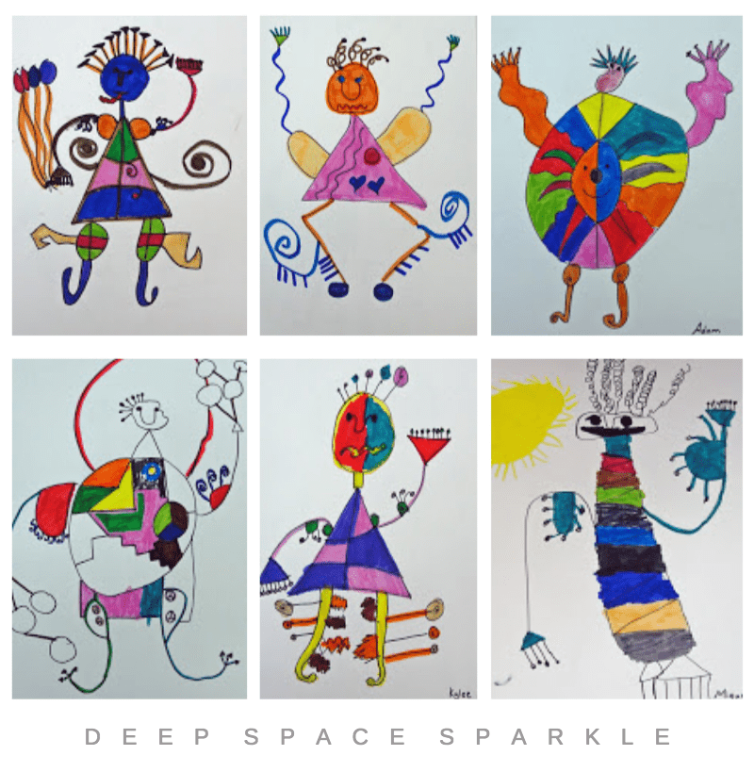  Joan Miro  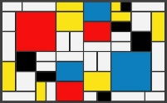  Piet Mondrian | 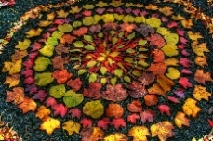  Andy Goldsworthy  Nature Sculpture Art  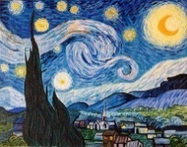  Van Gogh Starry Night | 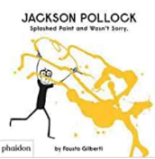  Jackson Pollock  Puppets: Chinese New Year |  | Design and Technology |  | 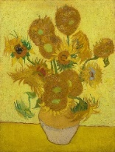  Van Gogh - Still life: drawing and painting sunflowers  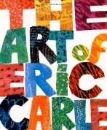  Eric Carle |  | Design and Technology
Creating with Materials | Self Portraits – Colour and Line  Colour mixing – different shades of skin tones. My family pictures.  - Explain what a portrait is and begin to identify the features of a portrait.  - To be able to use lines and colour to create a self-portrait – straight, wavy, zigzag.  - Manipulate malleable materials and objects showing a preference of a dominant hand.  Exploring colour. Painting with primary colours. Mixing secondary colours. Colour: naming, recognising and mixing primary colours  - Identify the primary colours: red, yellow and blue.  - Know how to mix poster paints to create different secondary colours.  - Know how to make a colour lighter using white paint. (tint)  Exploring line: in roads, maps and Miro/Mondrian  - Explain know who Miro is and identify the features in his artwork.  - Explain know who Mondrian Artist and identify the features in his artwork. | Observational Art and Nature Sculpture  Diva lamp using clay  - Manipulate malleable materials and objects showing a preference of a dominant hand.  - Impress and apply simple decoration.  Natural Art - Collaborative natural collage linked to Andy Goldsworthy and Autumn  - Explain who Andy Goldsworthy is and identify the features of his artwork.  - To identify different colours, shapes, patterns and textures in nature.  - How to use materials to create an object/piece of artwork.  Observational Drawings - Squashes and Mixing colours for Autumn leaves  - Know how to mix colours to create lighter and darker colours.  - To use and apply my knowledge of line to create an observational drawing.  Van Gogh – Starry Night  - Explain who Van Gogh is and identify the features of his artwork.  - Paint in the style on Van Gogh using the technique of spiral/swirl. | Painting Techniques  Winter Art  - Know how to make a colour lighter using white paint. (tint)  - To use and apply my knowledge of line to create an observational drawing.  Chinese New Year Puppets – folding techniques  - To explore the use of folding techniques.  - To construct with a purpose, using a variety of resources, simple tools and techniques.  Jackson Pollock - Creating drip paintings like Jackson Pollock.  - Explain know who the Artist Jackson Pollock is and identify the features in his artwork.  - To know who the artist Jackson Pollock is and features of his art work.  - Paint in the style of Jackson Pollock exploring painting techniques – drip, pour, splat. |  | Structures - Junk Modelling - Castles  Spring observational drawings – Watercolours  - Know how to mix colours to create lighter and darker colours.  - To use and apply my knowledge of line to create an observational drawing.  Create Easter bonnets  Junk Modelling – Castles  Design  - To learn how to plan and select the correct resources needed to make a model.  - To discuss what they want to make, constructing with a purpose.  Make  - To select appropriate resources  - To verbally plan and use my written plan to create a junk model castle.  Evaluate  - To share a finished model and talk about the processes in its creation.  Technique  - To learn about the different ways in which we can join materials together and to practise these techniques.  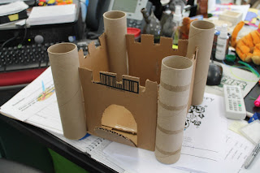  - To explore and investigate the tools and materials in the junk modelling area. |  | Still Life and Collage  Drawing and painting sunflowers, Studying Van Gogh.  Studying how Van Gogh used different marks to draw still life.  - To use and apply my knowledge of line and colour to create an observational drawing.  - Explain who Van Gogh is and identify the features of his artwork – still life.  - How feelings/moods can be created using colour and tone.  - Know how to mix colours to create lighter and darker colours.  - To explore hues of yellow to create a petal.  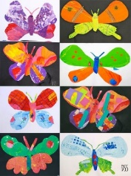  Collage – Eric Carle  - Use a variety of paper/material to create collage in the style of Eric Carle.  Spirals and Snails  - Explore creating patterns of spirals (Snails & Kandinsky)  - Manipulate malleable materials and objects showing a preference of a dominant hand.  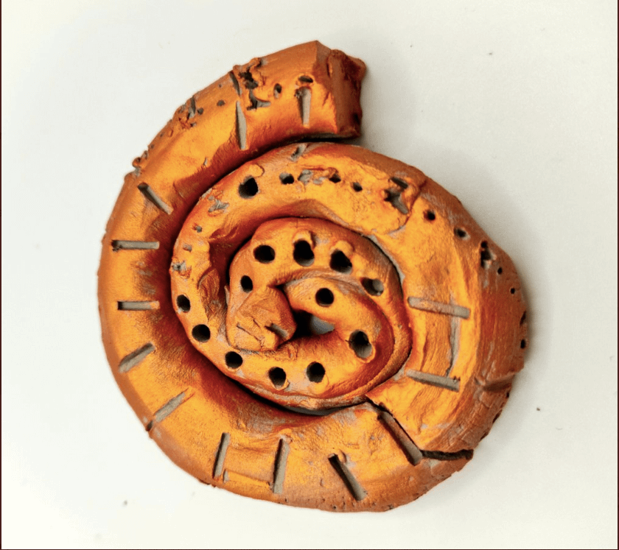  - To explore the properties of clay.  - Impress and apply simple decoration. |  | Design – Structures, Boats.  Design  - To learn how to plan and select the correct resources needed to make a model.  - To discuss what they want to make, constructing with a purpose.  Make  - To select appropriate resources  - To verbally plan and use my written plan to create a junk model boat.  Evaluate  - To share a finished model and talk about the processes in its creation.  - Talk about the suitability for different materials and reasons why.  - Look at similarities and differences between existing objects / materials / tools  - Discuss problems and how they might be solved as they arise.  Technique  - To learn about the different ways in which we can join materials together and to practise these techniques.  - To explore and investigate the tools and materials in the junk modelling area.
Being Imaginative and Expressive | Daily singing Nursery and Number rhymes as a whole class/ small group. Sing to singing hands to encourage the use of Makaton.  Rhythm, Pulse and Sound  Composer: Wolfgang Amadeus Mozart, Allegro from A Little Night Music. | Daily singing - introduce out of the ark as a whole class/ in a small group.  Perform the nativity performance  Watch a nativity  Christmas songs  Goodnight Little Seeds song  Composer: Sergei Prokofiev, Peter and the Wolf Vivaldi - Four Seasons | Listen to different types of music.  Dance and move expressively to music - Waltz of the snowflakes. The Nutcracker  Playing with Sounds: Pitch  Composer: Englebert Humperdinck, Hansel and Gretel |  | A Spring Thing song  Playing with Sounds: Singing Games including call and response  Express own feeling when listening to different types of music.  Composer: Handel- Zadok the priest- coronation music  The National Anthem |  | Move rhythmically to different types of music.  Instrumental Activities  Composer: Louis Armstrong Music and dance sessions: link to Carnival of the Animals Composer: Paul Dukas, The Sorcerer’s Apprentice |  | Perform to music of own choice Instrumental activities: Composition: using percussion instruments  Composer: G.F. Handel
ELG | ELG: Being Imaginative and Expressive  Invent, adapt and recount narratives and stories with peers and their teacher Sing a range of well-known nursery rhymes and songs. Perform songs, rhymes, poems and stories with others, and – when appropriate – try to move in time with music.  . |  |  |  | ELG: Creating with Materials  Safely use and explore a variety of materials, tools and techniques, experimenting with colour, design, texture, form and function.  Share their creations, explaining the process they have used.  Make use of props and materials when role playing characters in narratives and stories.
R.E | F4 Being special: where  do we belong? | F2 Why is Christmas  special for Christians?  [Incarnation] | F1 Why is the word  ‘God’ so important to  Christians? [God] |  | F3 Why is Easter special  for Christians? [Salvation] | F5: Which places are special and why? |  |  | F6: Which stories are special and why?

